Name: Ubaid Bin Waris
Regno: 2212416
CNDC Lab task 1 & 2

HTTP request using browser
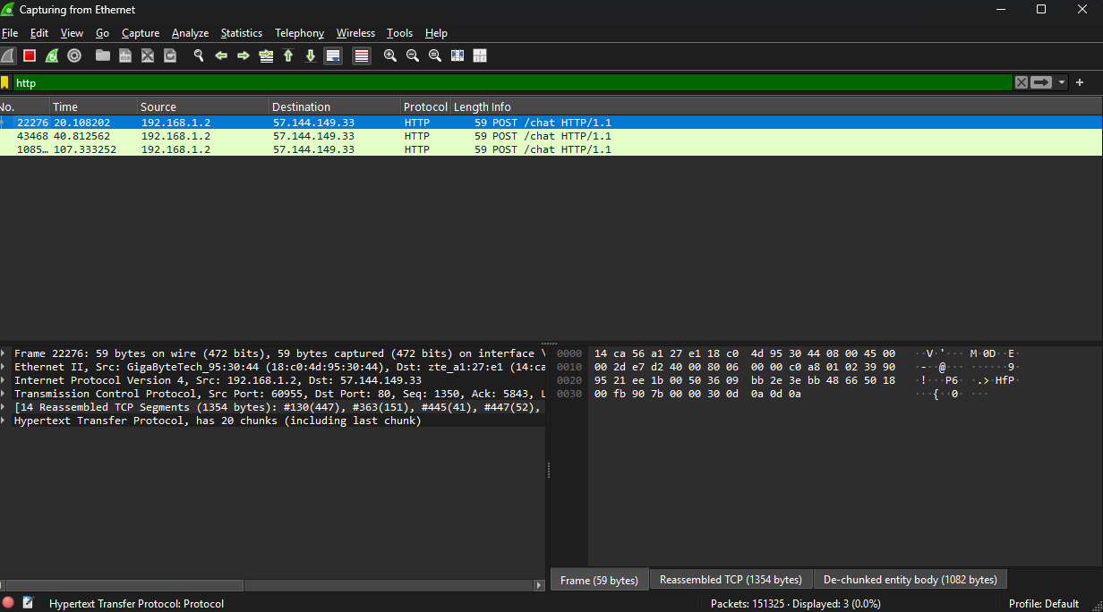

Connecting 2 systems using switch and pinging
